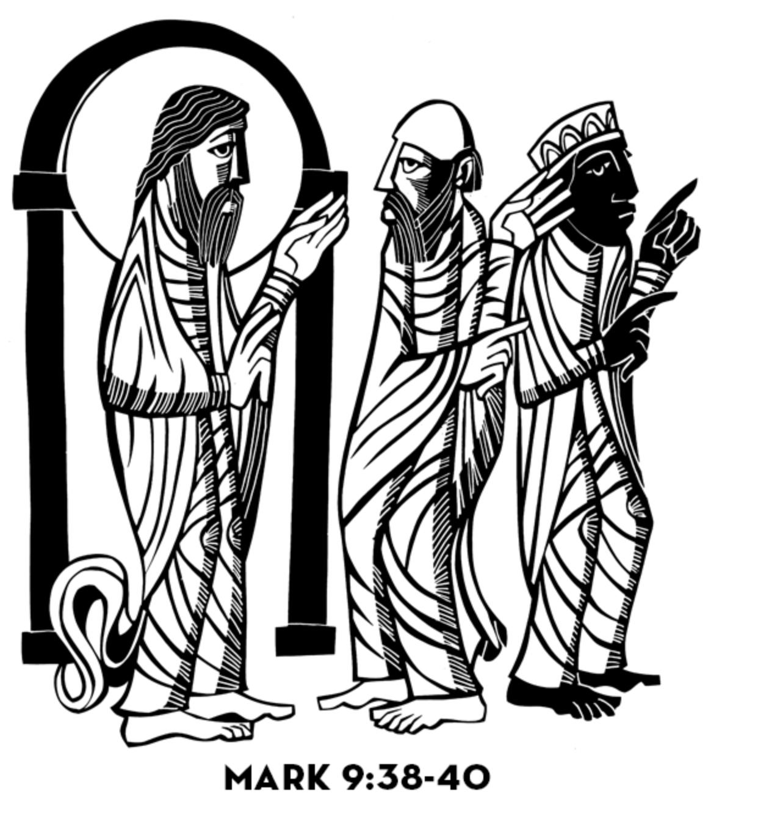**18th Sunday after Pentecost**

**CHRIST LUTHERAN CHURCH** | Lodi, California

*September 22, 2024*

**WELCOME TO WORSHIP**

Welcome to Christ Lutheran Church. We pray that your soul will be strengthened by the good news about God’s grace, love, and forgiveness given to us. If you would like to learn more about our church, please speak with our pastor or one of our members after the service.

* **Bathrooms** are located in the fellowship hall. A changing table is located in the women’s bathroom.

**WORSHIP THEME**

How will we serve Christ? In selfish ambition, with envy and division? Or in humility and unity? The answer seems obvious, but how easily we get in our own way as we seek to serve the Lord. May Christ grant us a true servant’s heart as we serve Him in His kingdom.



***Setting II***

*We gather as a congregation to hear God’s Word proclaimed and respond with prayer, praise, and thanksgiving.*

**HYMN** *Lord, Help Us Walk Your Servant Way* **| CW 737**

M: In the name of the Father, and of the Son, and of the Holy Spirit.

**C: Amen.**

**CONFESSION**

M: If we claim to be without sin, we deceive ourselves and the truth is not in us.

**C: If we confess our sins, God is faithful and just   
 and will forgive us our sins   
 and purify us from all unrighteousness.**

M: Let us confess our sins to the Lord.

**C: Holy God, gracious Father,   
 I am sinful by nature   
 and have sinned against you in my thoughts, words, and actions.   
 I have not loved you with my whole heart;   
 I have not loved others as I should.   
 I deserve your punishment both now and forever.   
 But Jesus, my Savior, paid for my sins   
 with his innocent suffering and death.   
 Trusting in him, I pray: God, have mercy on me, a sinner.**

*Silence for meditation and reflection*

# absolution

M: Our gracious Father in heaven has been merciful to us. He sent his only Son, Jesus Christ, who gave his life as the atoning sacrifice for the sins of the whole world. Therefore, as a called servant of Christ and by his authority, I forgive you all your sins in the name of the Father and of the ✙ Son and of the Holy Spirit.

**C: Amen.**

**Lord, Have Mercy**

M: In peace let us pray to the Lord.

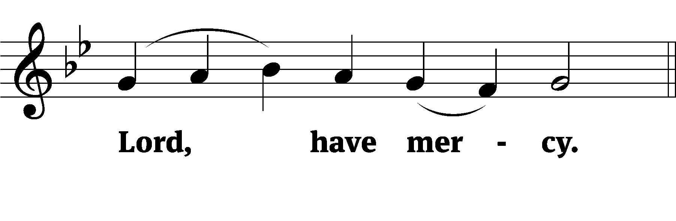

M: For the peace from above and for our salvation, let us pray to the Lord.

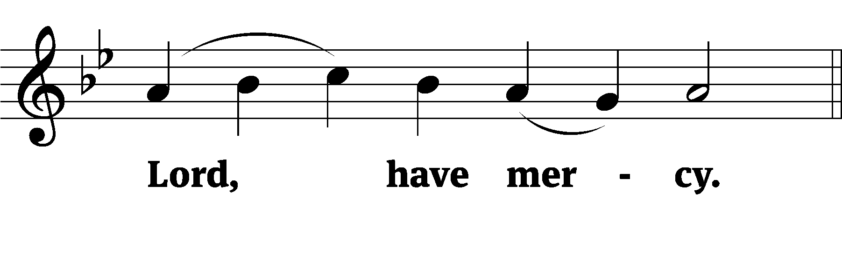

M: For the peace of the whole world, for the well-being of the Church of God, and for the unity of all, let us pray to the Lord.

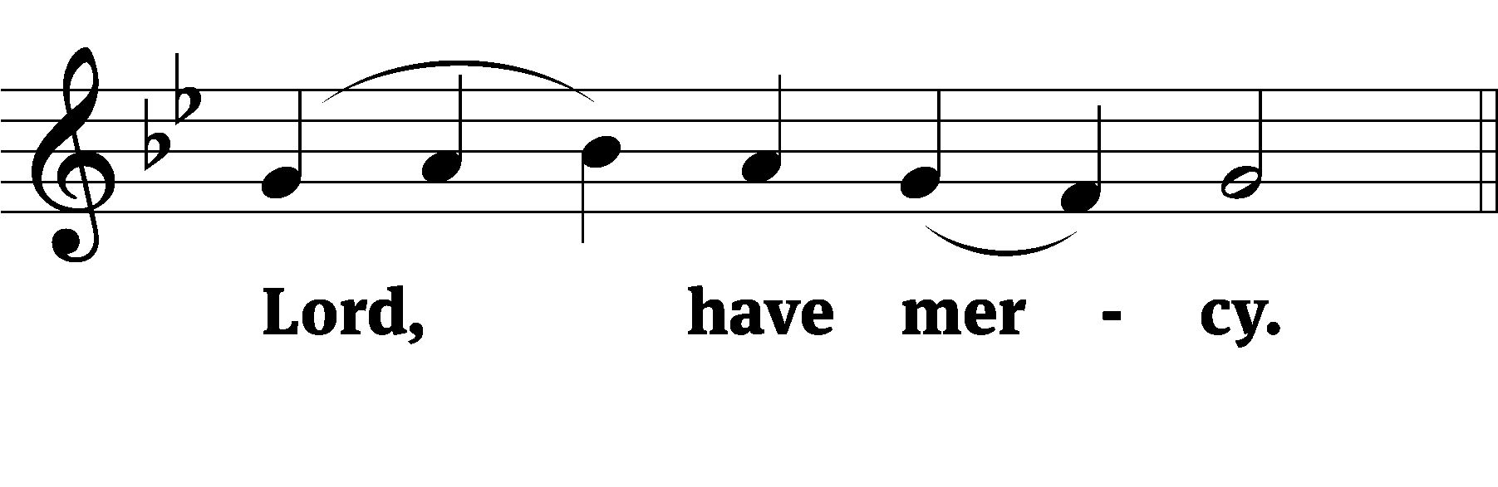

M: For this holy house and for all who offer here their worship and praise, let us pray to the Lord.

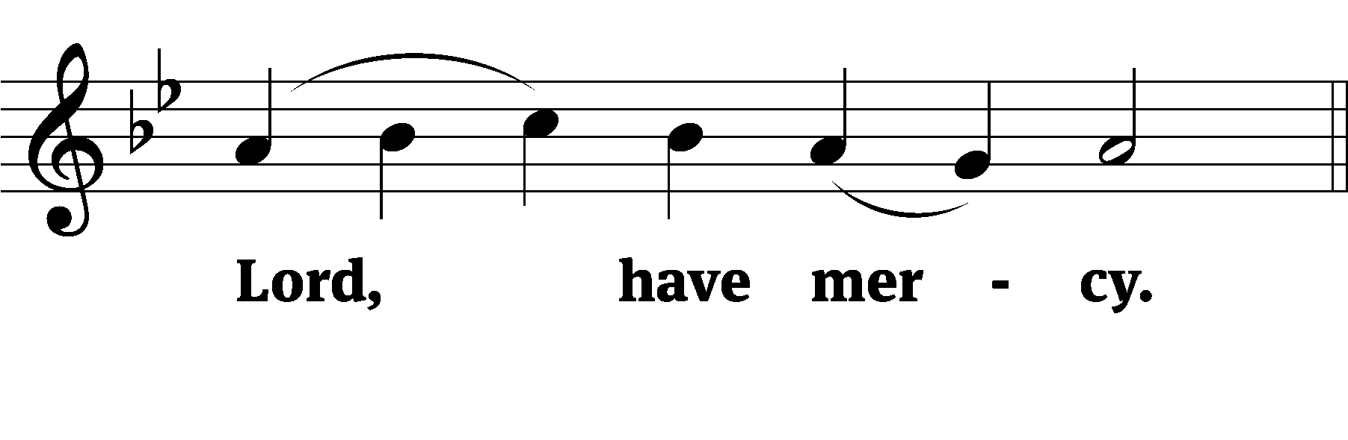

M: Help, save, comfort, and defend us, gracious Lord.

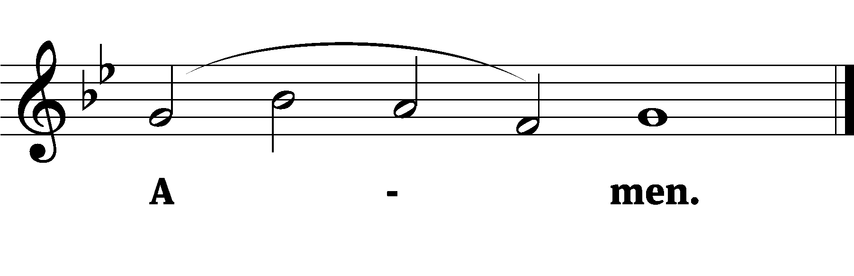

**Glory to God in the highest**



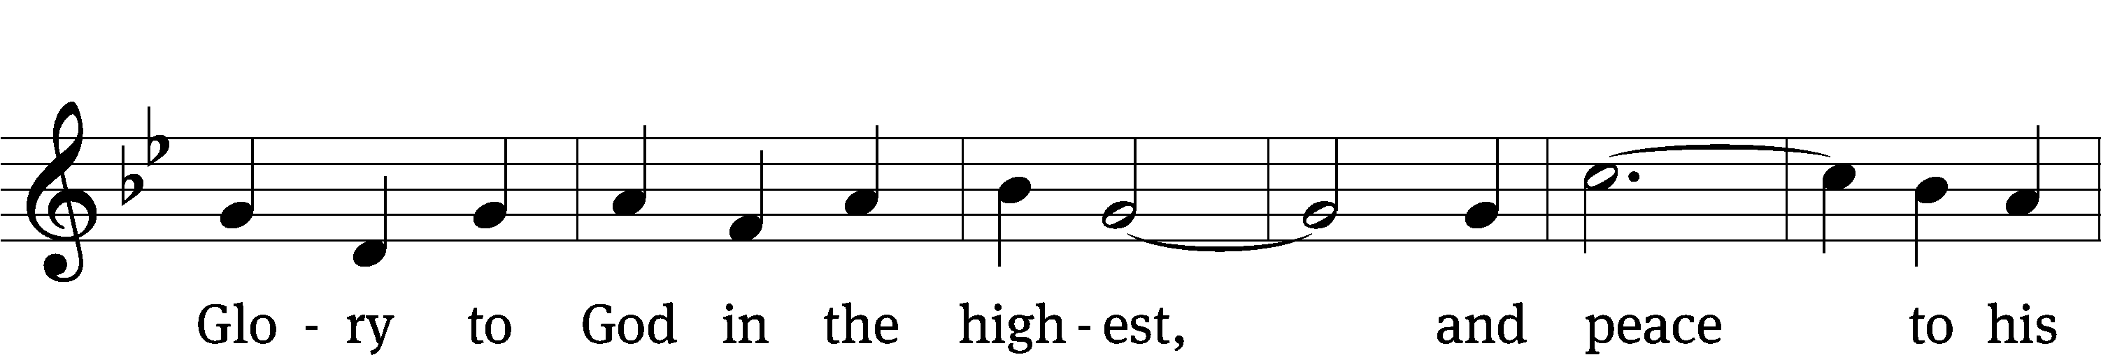

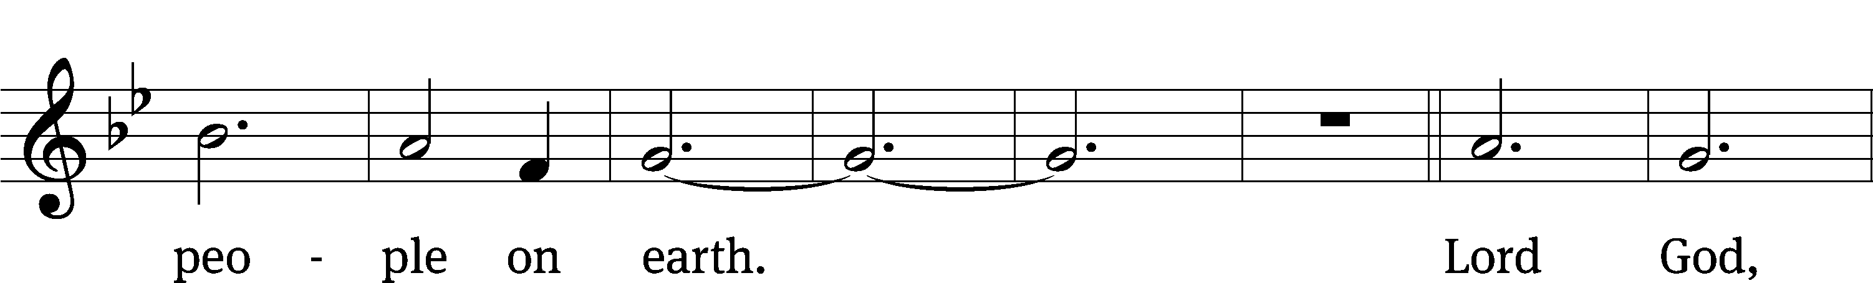

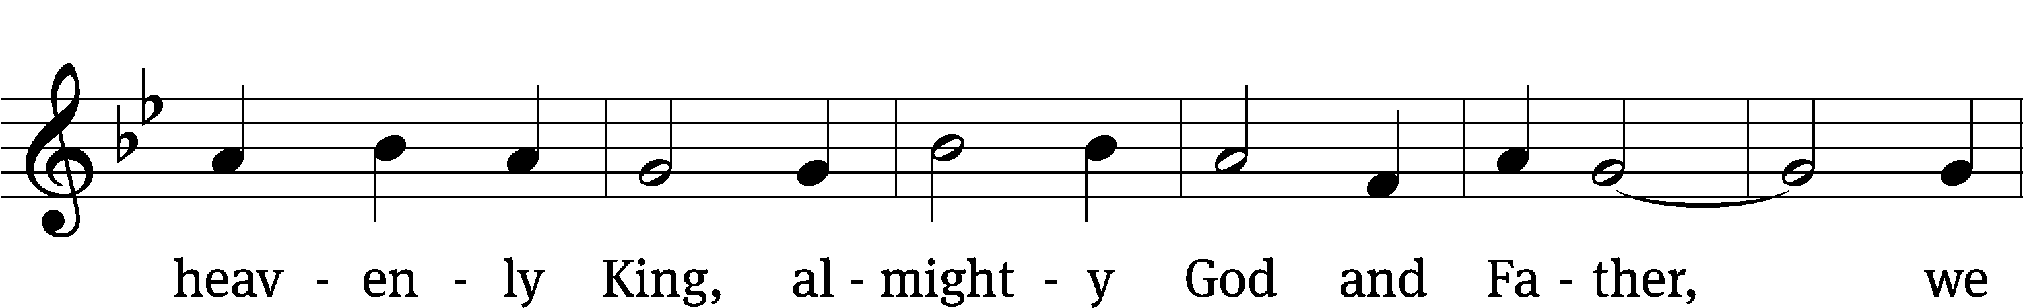

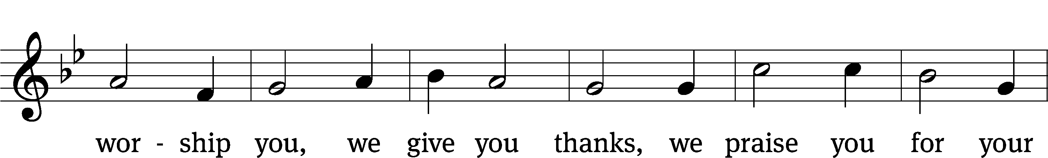

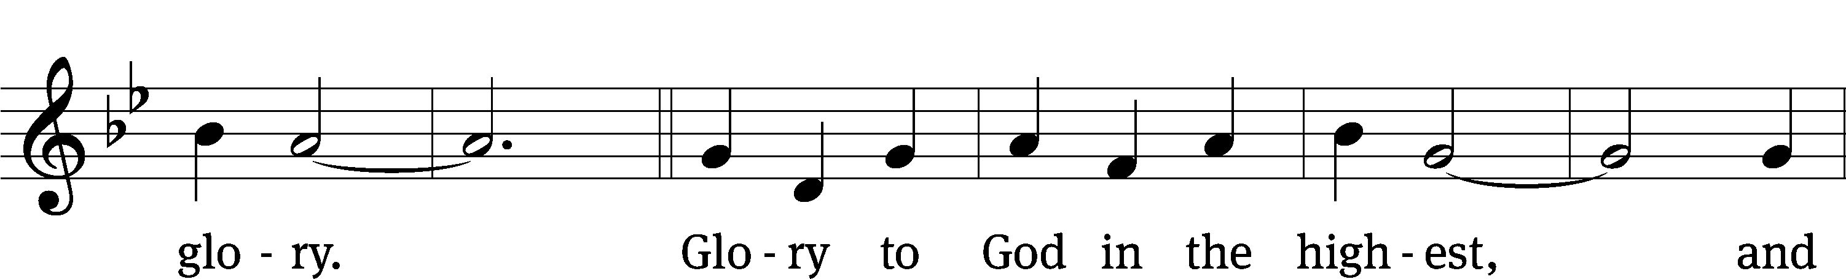

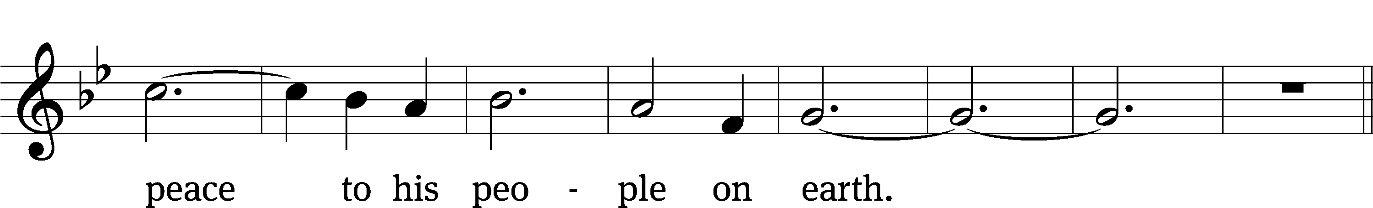

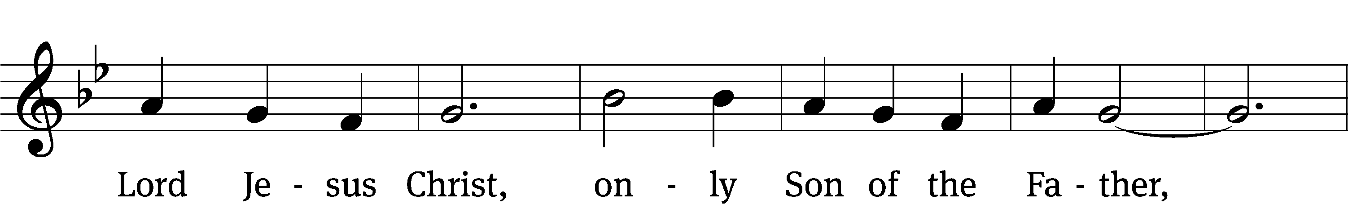

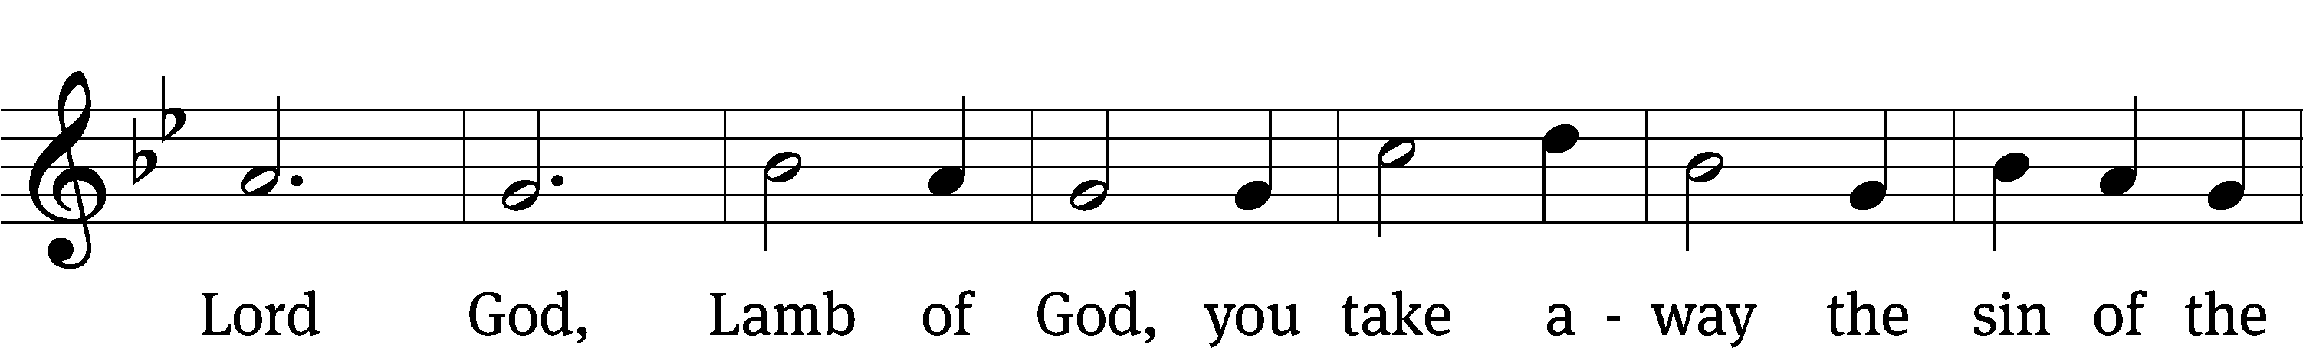

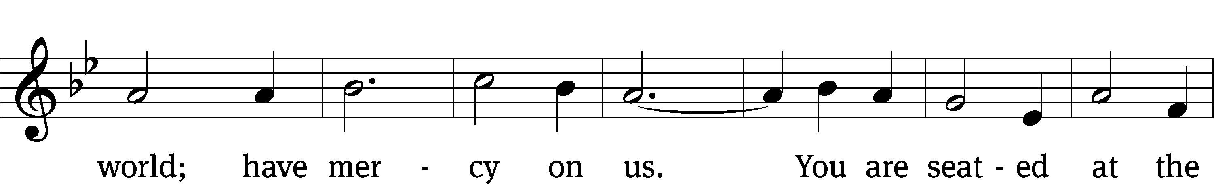

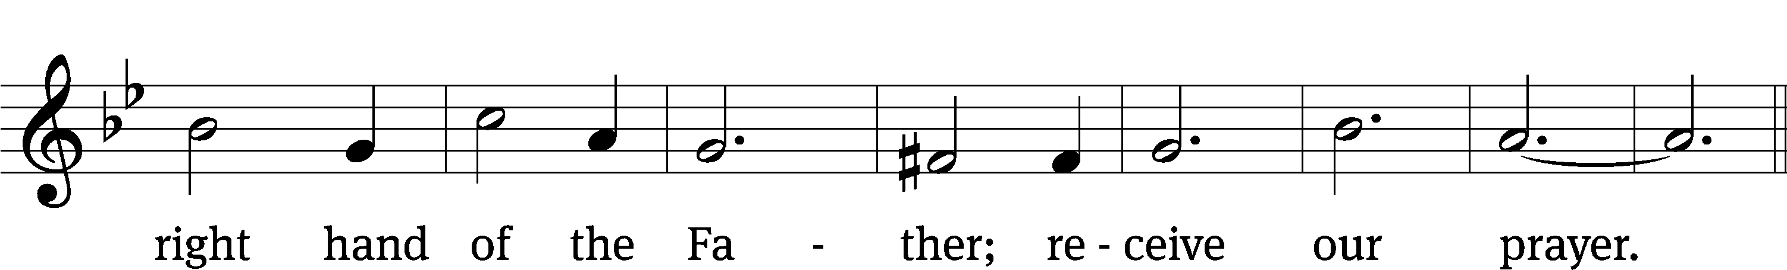

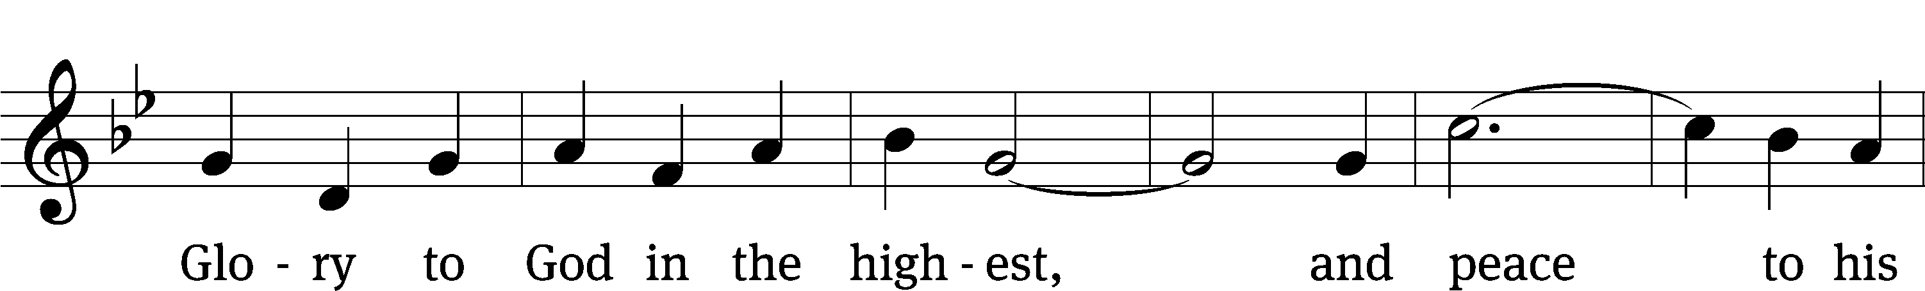

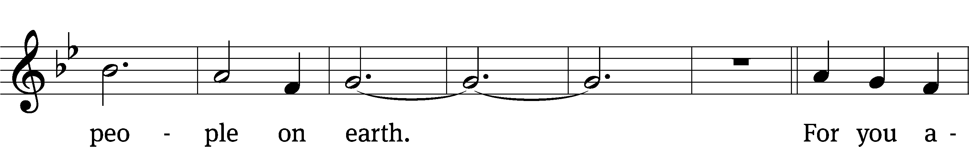

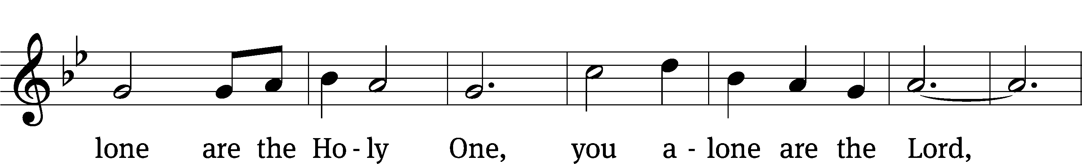

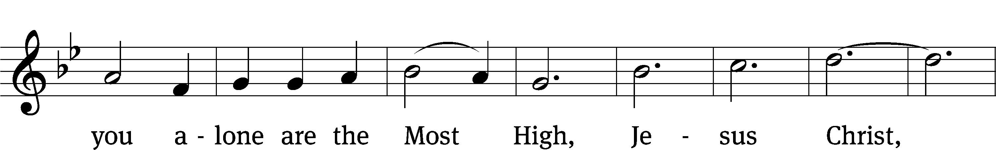

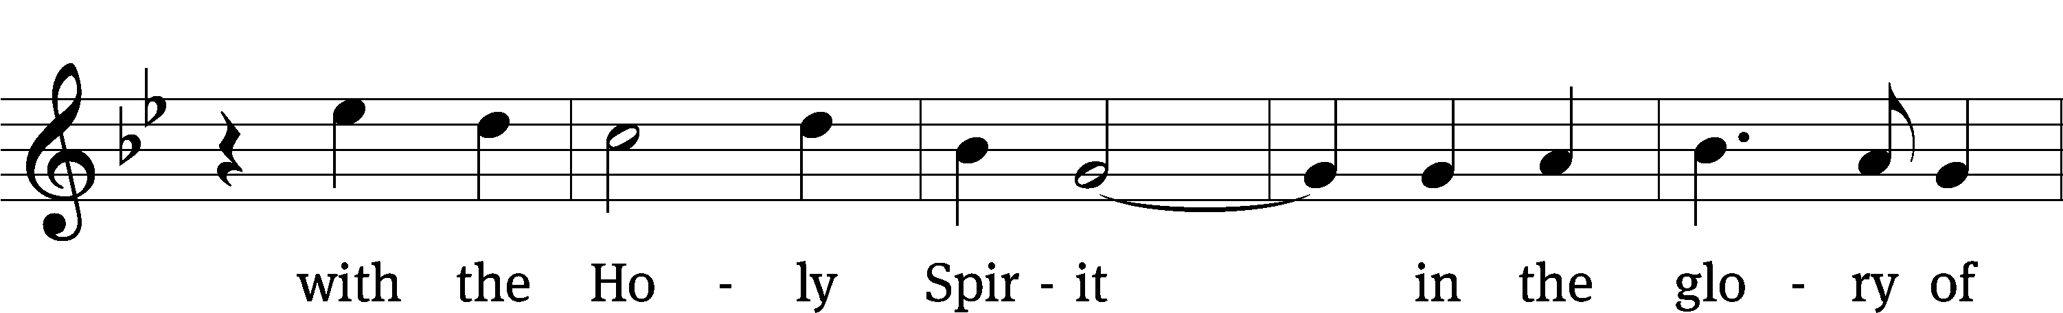

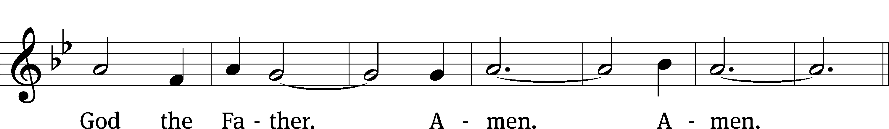

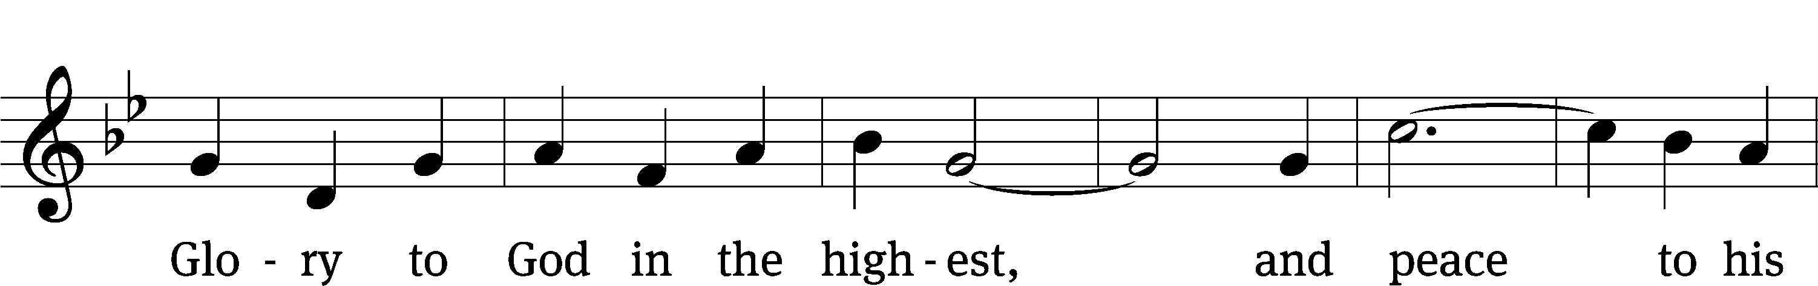

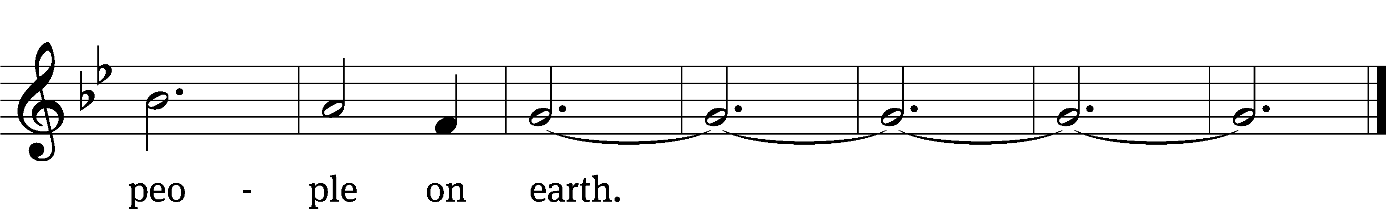

**PRAYER OF THE DAY**

M: Let us pray.

Mercifully grant, O God, that your Holy Spirit may in all things direct and rule our hearts, for without your help we are unable to please you; through Jesus Christ, your Son, our Lord, who lives and reigns with you and the Holy Spirit, one God, now and forever.

**C: Amen.**

**FIRST LESSON** *Numbers 11:16, 24-29*

*Service in God’s Kingdom is service to the Lord and not our own pride.*

**16**The Lord said to Moses: “Bring me seventy of Israel’s elders who are known to you as leaders and officials among the people. Have them come to the tent of meeting, that they may stand there with you.

**24**So Moses went out and told the people what the Lord had said. He brought together seventy of their elders and had them stand around the tent. **25**Then the Lord came down in the cloud and spoke with him, and he took some of the power of the Spirit that was on him and put it on the seventy elders. When the Spirit rested on them, they prophesied—but did not do so again.

**26**However, two men, whose names were Eldad and Medad, had remained in the camp. They were listed among the elders, but did not go out to the tent. Yet the Spirit also rested on them, and they prophesied in the camp. **27**A young man ran and told Moses, “Eldad and Medad are prophesying in the camp.”

**28**Joshua son of Nun, who had been Moses’ aide since youth, spoke up and said, “Moses, my lord, stop them!”

**29**But Moses replied, “Are you jealous for my sake? I wish that all the Lord’s people were prophets and that the Lord would put his Spirit on them!”

**PSALM** *Psalm 51, CW’21*

**SECOND LESSON** *Philippians 1:12-18*

*Rejoice that Christ is preached.*

**12**Now I want you to know, brothers and sisters,[[a](https://www.biblegateway.com/passage/?search=Philippians%201%3A12-18&version=NIV#fen-NIV-29374a)] that what has happened to me has actually served to advance the gospel. **13**As a result, it has become clear throughout the whole palace guard[[b](https://www.biblegateway.com/passage/?search=Philippians%201%3A12-18&version=NIV#fen-NIV-29375b)] and to everyone else that I am in chains for Christ. **14**And because of my chains, most of the brothers and sisters have become confident in the Lord and dare all the more to proclaim the gospel without fear.

**15**It is true that some preach Christ out of envy and rivalry, but others out of goodwill. **16**The latter do so out of love, knowing that I am put here for the defense of the gospel. **17**The former preach Christ out of selfish ambition, not sincerely, supposing that they can stir up trouble for me while I am in chains. **18**But what does it matter? The important thing is that in every way, whether from false motives or true, Christ is preached. And because of this I rejoice.

Yes, and I will continue to rejoice.

**VERSE OF THE DAY** *Philippians 2:10,11*

**Alleluia. At the name of Jesus every knee should bow, and every tongue confess that Jesus Christ is Lord, to the glory of God the Father. Alleluia.**

**THE GOSPEL** *Mark 9:38-50*

*Let nothing get in the way of the gospel.*

**38**“Teacher,” said John, “we saw someone driving out demons in your name and we told him to stop, because he was not one of us.”

**39**“Do not stop him,” Jesus said. “For no one who does a miracle in my name can in the next moment say anything bad about me, **40**for whoever is not against us is for us. **41**Truly I tell you, anyone who gives you a cup of water in my name because you belong to the Messiah will certainly not lose their reward.

**42**“If anyone causes one of these little ones—those who believe in me—to stumble, it would be better for them if a large millstone were hung around their neck and they were thrown into the sea. **43**If your hand causes you to stumble, cut it off. It is better for you to enter life maimed than with two hands to go into hell, where the fire never goes out.  **45**And if your foot causes you to stumble, cut it off. It is better for you to enter life crippled than to have two feet and be thrown into hell. **47**And if your eye causes you to stumble, pluck it out. It is better for you to enter the kingdom of God with one eye than to have two eyes and be thrown into hell, **48**where

‘the worms that eat them do not die,  
    and the fire is not quenched.’

**49**Everyone will be salted with fire.

**50**“Salt is good, but if it loses its saltiness, how can you make it salty again? Have salt among yourselves, and be at peace with each other.”

M This is the Gospel of the Lord.

**C: Praise be to you, O Christ!**

**HYMN OF THE DAY** *Lord of Glory, You Have Bought Us***| CW 767**

**SERMON** *Mark 9*

**APOSTLES’ CREED**

**I believe in God, the Father Almighty,**

**maker of heaven and earth.**

**I believe in Jesus Christ, his only Son, our Lord,**

**who was conceived by the Holy Spirit,**

**born of the Virgin Mary,**

**suffered under Pontius Pilate,**

**was crucified, died, and was buried.**

**He descended into hell.**

**The third day he rose again from the dead.**

**He ascended into heaven**

**and is seated at the right hand of God the Father Almighty.**

**From there he will come to judge the living and the dead.**

**I believe in the Holy Spirit,**

**the holy Christian Church,**

**the communion of saints,**

**the forgiveness of sins,**

**the resurrection of the body,**

**and the life everlasting. Amen.**

**OFFERING**

*In response to God’s love and forgiveness, we give back a portion of what he has given us. The members of Christ Lutheran Church have joined to proclaim the gospel to this community. These offerings support that work. While our guests are welcome to participate, they should not feel obligated to do so.*

**PRAYER OF THE CHURCH**

M: Heavenly Father, You have taken us from all nations and united us in the Body of Your Son. Send Your Holy Spirit to rid Your children of all bitter jealousy, boasting and selfish ambition. Fill the baptized with Your wisdom, that we may lead peaceable lives with sincerity and love. Lord, in Your mercy,

**C: Hear our prayer.**

M: O Lord of hosts, give our Synod’s leaders and all pastors the wisdom that comes down from above, that they may be peaceable, gentle, open to reason, full of mercy and good fruits, impartial, and sincere. Let them sow among us in peace, and grant a harvest of righteousness. Lord, in Your mercy,

**C: Hear our prayer.**

M: Uphold this world in Your order. Preserve the Church and the preaching of Your Word against all enemies. Bless our homes, that parents and children may serve one another faithfully and grow in instruction and faith until life’s end. Give health and wisdom to all who serve in public office, that their authority may be exercised for the benefit of our people. Lord, in Your mercy,

**C: Hear our prayer.**

M: Lord, in Your lovingkindness You do not abandon Your children to suffer alone but promise to care for all who call upon Your name. Bless the homebound, the lonely, the depressed and anxious, those preparing for surgery, the ill and the dying [and especially those who desire our prayers: _____________]. Comfort them in their distress, heal all their ills of body and soul, and grant them Your peace. Lord, in Your mercy,

**C: Hear our prayer.**

M: Father, grant that what we ask from You may not be squandered after our passions but sought rightly in faith, that we may receive them and put them into service for You and our neighbors. Into Your hands, we commend all for whom we pray, trusting in Your mercy; through Jesus Christ, Your Son, our Lord, who lives and reigns with You and the Holy Spirit, one God, now and forever.

**C: Amen.**

**LORD’S PRAYER**

**C: Our Father, who art in heaven,**

**hallowed be thy name,**

**thy kingdom come,**

**thy will be done on earth as it is in heaven.**

**Give us this day our daily bread;**

**and forgive us our trespasses,**

**as we forgive those**

**who trespass against us;**

**and lead us not into temptation,**

**but deliver us from evil.**

**For thine is the kingdom**

**and the power and the glory**

**forever and ever. Amen.**

M: O Lord God, our heavenly Father, pour out the Holy Spirit on your faithful people. Keep us strong in your grace and truth, protect and comfort us in all temptation, and bestow on us your saving peace, through Jesus Christ, our Lord.

**C: Amen.**

**THE BLESSING**

M**:** The Lord bless you and keep you.

The Lord make his face shine on you and be gracious to you.

The Lord look on you with favor and ✙ give you peace.

**C: Amen.**

**CLOSING HYMN** *Let Us Ever Walk With Jesus***| CW 704**

**COPYRIGHT INFORMATION**

*Content requiring a copyright license is reproduced under OneLicense.net #A-718312. All rights reserved. The Common Service: Texts revised from The Lutheran Hymnal, 1941. Music revised by James Engel. Scripture Quotations: From the Holy Bible, New International Version (NIV 1984), © 1973, 1978, 1984 by Biblica, Inc.*



**13009 N. Elderberry Ct.**

**Lodi, CA 95242**

[www.christlodi.org](http://www.christlodi.org)

209-368-6250

Pastor Tim Leistekow

**WELCOME TO CHRIST EV. LUTHERAN CHURCH!**

We preach a message of forgiveness, hope and peace

through the death and resurrection of Jesus Christ.

Families and individuals of all ages will find opportunities

both to grow and to serve.

Our mission statement:

**Look what Christ is doing!**

He binds us together in fellowship

He gathers us in for worship

He builds us up for service

He sends us out with the gospel

*“Now you are the body of Christ,*

*and each one of you is a part of it.”*

*(1 Corinthians 12:27)*